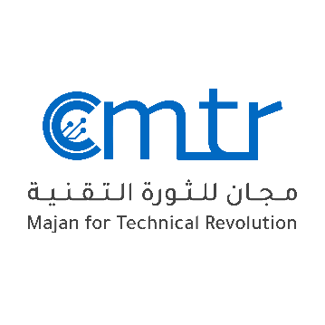
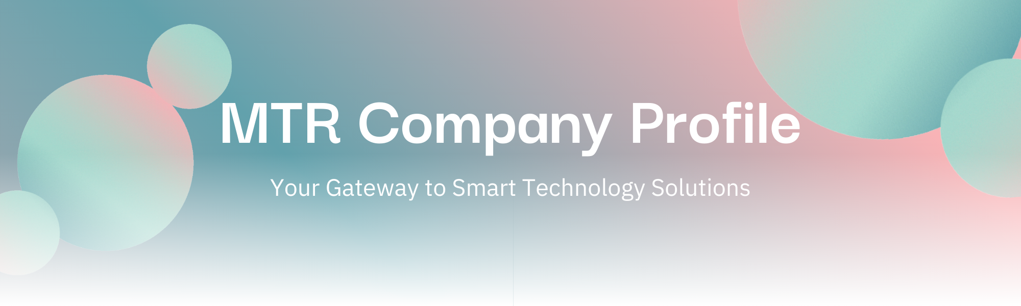
MTR Company Profile


About Us
At MTR, we are passionate about empowering businesses through smart technology solutions.
Our Journey
Founded with a vision to bridge the
gap between business needs and
innovative IT services, MTR has grown into a trusted technology partner for companies across multiple industries. Our journey is rooted in the belief that technology should not only support but also enhance the core functions of any business.
Company Overview
Majan Technical Revolution (MTR) is a pioneering force in the Information Technology sector, committed to delivering innovative, customer-centric solutions that drive operational excellence and digital advancement. At the heart of MTR’s approach is a dedication to transforming businesses through scalable technologies, ensuring optimal performance, security, and growth across various industries.

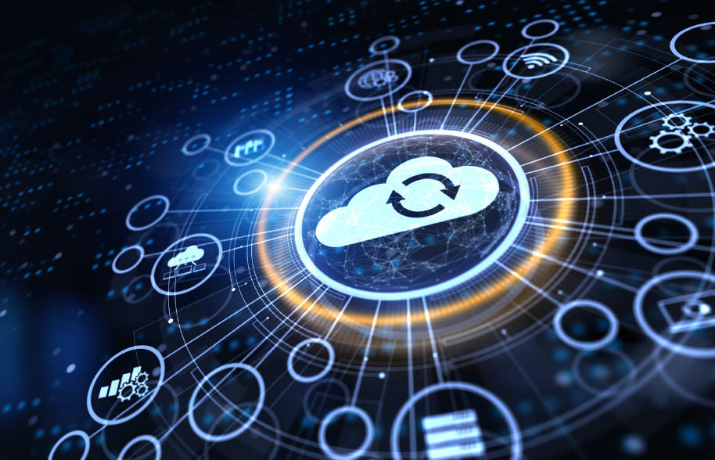
Our Specializations
We specialize in a wide range of services, including:
- Azure Server
- Cloud Computing
- Networking Solutions
- Learning Management System (LMS) Management
- Smart Management Solutions
- Full IT Infrastructure Services
Our expertise ensures we address the diverse technological needs of our clients, tailoring solutions to fit their unique objectives.

Our Commitment
With a strong focus on quality, security, and customer satisfaction, we ensure that every solution we deliver is designed to meet the specific needs and goals of our clients.

Our Mission
To deliver cutting-edge technology solutions that drive success, optimize operations, and create sustainable growth for our clients.

Our Vision
To be a leading global provider of innovative IT services, known for excellence, reliability, and customer-first thinking.

Our Values
- Innovation: Always seeking smarter, more efficient solutions.
- Integrity: Building trust through honesty, transparency, and responsibility.
- Customer Focus: Putting our clients’ success at the heart of everything we do.
- Quality Commitment: Delivering services that meet the highest standards.
- Continuous Improvement: Learning, evolving, and growing with technology trends.

Why Choose MTR?
With a team of experienced engineers, developers, and IT consultants, we don’t just offer services — we create partnerships that foster growth and digital transformation.
- Experience & Expertise: IT solutions delivered across education, finance, healthcare, and more
- End-to-End Service: From idea to implementation, with continuous support
- Quality Commitment: Industry standards, best practices, and client satisfaction
- Tailored Solutions: Customized for your business size, industry, and goals
- 24/7 Support: Fast resolution, minimal disruption, anytime and anywhere

Our Services
We deliver comprehensive IT solutions that help businesses operate more efficiently, securely, and innovatively. Our expert team partners with clients at every step — from consultation and design to deployment, management, and ongoing support.
1️⃣ Azure Server Management & Configuration
What it is: Full lifecycle management of cloud servers hosted on Microsoft Azure.
Key Offerings
- Server setup & optimization
- Performance monitoring
- Security hardening
- Load balancing & autoscaling
- Continuous health monitoring
Why it matters: Scalable, secure servers — no infrastructure hassle, improved uptime, and cost efficiency.
2️⃣ Learning Management System (LMS) Management

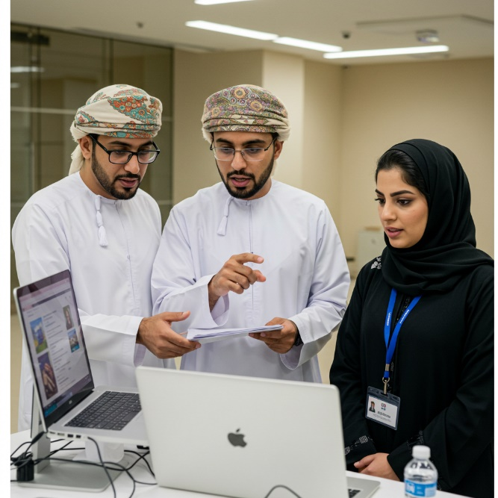
Specializing in platforms like Moodle and Blackboard, MTR delivers:
- Full-cycle LMS deployment
- Custom theme design and branding
- Course and user management
- Training and platform integration
Our team helps you create engaging and efficient e-learning environments for academic institutions and corporations.

3️⃣ Networking Solutions
MTR designs, deploys, and maintains secure, reliable networks with services including:
- LAN, WAN, and VPN configuration
- Wireless network design
- Advanced firewall implementation
- 24/7 monitoring and support
We ensure connectivity without compromise, enhancing productivity and resilience.
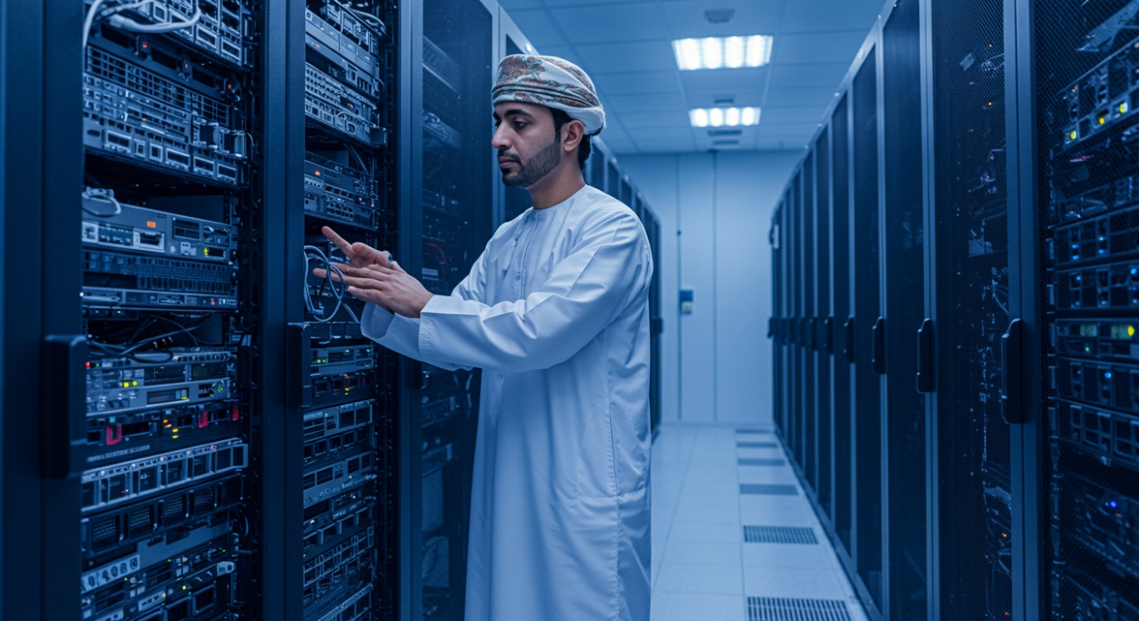 4️⃣ Cloud Computing Services
From readiness to migration and optimization, we support:
- Azure and AWS cloud integration
- Multi-cloud strategies
- Data migration and hybrid solutions

- Comprehensive cloud security
We enable businesses to scale, innovate, and respond dynamically in a fast-paced digital world.

Key Offerings
- IoT monitoring & dashboards
- Business process automation
- Smart office solutions
- Real-time analytics & mobile control
Why it matters: Save time, reduce costs, and make data-driven decisions faster.
📊 Smart Management Solutions
Harnessing IoT and automation, MTR offers:
- Real-time monitoring and analytics
- Mobile and web integration

- Business process automation
- Custom smart dashboards
These solutions turn data into actionable intelligence, enhancing decision-making and performance.


Additional IT Services
Service | Explanation
Cloud Migration & Optimization | Move your entire IT environment to the cloud and ensure it runs efficiently, securely, and cost-effectively.
Full IT Infrastructure Setup & Maintenance | From servers to workstations, printers, and networks — we build and maintain complete IT environments.
Web Application Design & Development | Custom websites, portals, and apps that streamline operations, enhance engagement, and generate revenue.
Data Backup & Disaster Recovery | Secure, automated backups and recovery plans to minimize data loss and downtime.
Cybersecurity Assessments & Solutions | Vulnerability scans, penetration testing, and security fixes to protect against cyber threats.
Custom Software Development & Integration | Tailored software that fits business workflows and integrates with existing systems.
Network Security Monitoring | Continuous monitoring of network activity with rapid threat response.
24/7 Remote & Onsite Support | Helpdesk and engineers provide fast, reliable IT support anytime, anywhere.
Technology Consulting & Digital Transformation | IT strategy, process improvements, and modern tech advice to enhance competitiveness.

Conclusion
At Majan Technical Revolution, we don’t just implement technology—we enable transformation. Whether you're scaling to the cloud, optimizing operations, or revolutionizing your digital ecosystem, MTR is your trusted partner in progress.


📞 Ready to take your IT to the next level?
Contact MTR for a free consultation today!
📧 info@mtr.digital

